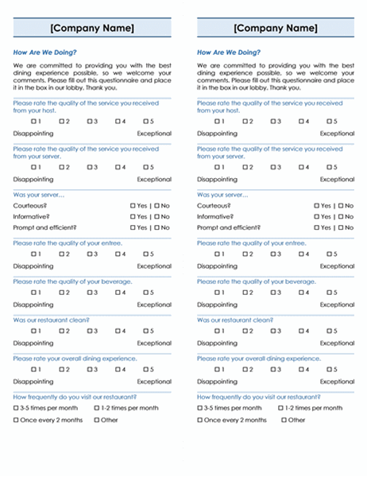  Restaurant Survey | Learn More From Our Free Excel and Office Resources:  - Webinars: Formulas, Pivot Tables and Macros & VBA  - Blog Tutorials: Formulas, Pivot Tables, Charts, Macros, VBA, Power Query, Power Pivot, Analysis  - Excel Podcast: Interviewing the Excel Experts  MyExcelOnline

[Company Name]  How Are We Doing?  We are committed to providing you with the best dining experience possible, so we welcome your comments. Please fill out this questionnaire and place it in the box in our lobby. Thank you.  Please rate the quality of the service you received from your host.  1 2 3 4 5  Disappointing Exceptional  Please rate the quality of the service you received from your server.  1 2 3 4 5  Disappointing Exceptional  Was your server…  Courteous? Yes | No  Informative? Yes | No  Prompt and efficient? Yes | No  Please rate the quality of your entree.  1 2 3 4 5  Disappointing Exceptional  Please rate the quality of your beverage.  1 2 3 4 5  Disappointing Exceptional  Was our restaurant clean?  1 2 3 4 5  Disappointing Exceptional  Please rate your overall dining experience.  1 2 3 4 5  Disappointing Exceptional  How frequently do you visit our restaurant?  3-5 times per month 1-2 times per month  Once every 2 months Other |  | [Company Name]  How Are We Doing?  We are committed to providing you with the best dining experience possible, so we welcome your comments. Please fill out this questionnaire and place it in the box in our lobby. Thank you.  Please rate the quality of the service you received from your host.  1 2 3 4 5  Disappointing Exceptional  Please rate the quality of the service you received from your server.  1 2 3 4 5  Disappointing Exceptional  Was your server…  Courteous? Yes | No  Informative? Yes | No  Prompt and efficient? Yes | No  Please rate the quality of your entree.  1 2 3 4 5  Disappointing Exceptional  Please rate the quality of your beverage.  1 2 3 4 5  Disappointing Exceptional  Was our restaurant clean?  1 2 3 4 5  Disappointing Exceptional  Please rate your overall dining experience.  1 2 3 4 5  Disappointing Exceptional  How frequently do you visit our restaurant?  3-5 times per month 1-2 times per month  Once every 2 months Other

[Company Name] |  | [Company Name]
Continued |  | Continued
Do you plan to return to our restaurant?  Yes | No |  | Do you plan to return to our restaurant?  Yes | No
Would you recommend our restaurant to a friend? |  | Would you recommend our restaurant to a friend?
Yes | No |  | Yes | No
Why, or why not? |  | Why, or why not?
If your visit was to celebrate a special occasion, how might we have made it more memorable? |  | If your visit was to celebrate a special occasion, how might we have made it more memorable?
What dish did you order? |  | What dish did you order?
What dishes would you like added to our menu? |  | What dishes would you like added to our menu?
Please share any additional comments or suggestions. |  | Please share any additional comments or suggestions.
[Company Name]  [Address]  City, ST ZIP Code  [Phone]  [Website] |  | [Company Name]  [Address]  City, ST ZIP Code  [Phone]  [Website]

