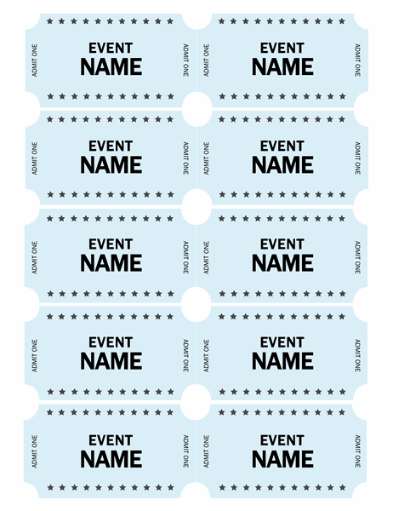  STAR CONCERT TICKETS | Learn More From Our Free Excel and Office Resources:  - Webinars: Formulas, Pivot Tables and Macros & VBA  - Blog Tutorials: Formulas, Pivot Tables, Charts, Macros, VBA, Power Query, Power Pivot, Analysis  - Excel Podcast: Interviewing the Excel Experts  MyExcelOnline

- Event  Name | - Event  Name
- Event  Name | - Event  Name
- Event  Name | - Event  Name
- Event  Name | - Event  Name
- Event  Name | - Event  Name

