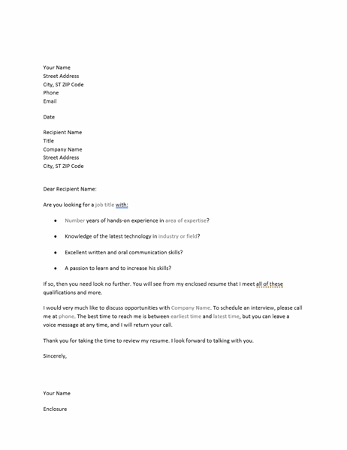  cover letter for unsolicited resume | Learn More From Our Free Excel and Office Resources:  - Webinars: Formulas, Pivot Tables and Macros & VBA  - Blog Tutorials: Formulas, Pivot Tables, Charts, Macros, VBA, Power Query, Power Pivot, Analysis  - Excel Podcast: Interviewing the Excel Experts  MyExcelOnline

Your Name
Street Address
City, ST ZIP Code
Phone
Email
Date
Recipient Name
Title
Company Name
Street Address
City, ST ZIP Code
Dear Recipient Name:
Are you looking for a job title with:
- Number years of hands-on experience in area of expertise?
- Knowledge of the latest technology in industry or field?
- Excellent written and oral communication skills?
- A passion to learn and to increase his skills?
If so, then you need look no further. You will see from my enclosed resume that I meet all of these qualifications and more.
I would very much like to discuss opportunities with Company Name. To schedule an interview, please call me at phone. The best time to reach me is between earliest time and latest time, but you can leave a voice message at any time, and I will return your call.
Thank you for taking the time to review my resume. I look forward to talking with you.
Sincerely,
Your Name
Enclosure

