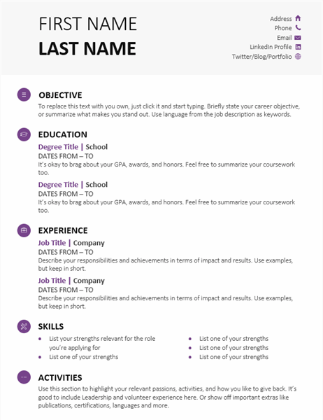  Student Resume | Learn More From Our Free Excel and Office Resources:  - Webinars: Formulas, Pivot Tables and Macros & VBA  - Blog Tutorials: Formulas, Pivot Tables, Charts, Macros, VBA, Power Query, Power Pivot, Analysis  - Excel Podcast: Interviewing the Excel Experts  MyExcelOnline

First Name  - Last Name | Address  Phone  Email  LinkedIn Profile  Twitter/Blog/Portfolio

Objective
To replace this text with you own, just click it and start typing. Briefly state your career objective, or summarize what makes you stand out. Use language from the job description as keywords.

Education

Degree Title | School

Dates From – To
It’s okay to brag about your GPA, awards, and honors. Feel free to summarize your coursework too.

Degree Title | School

Dates From – To
It’s okay to brag about your GPA, awards, and honors. Feel free to summarize your coursework too.

Experience

Job Title | Company

Dates From – To
Describe your responsibilities and achievements in terms of impact and results. Use examples, but keep in short.

Job Title | Company

Dates From – To
Describe your responsibilities and achievements in terms of impact and results. Use examples, but keep in short.

Skills
- List your strengths relevant for the role you’re applying for  - List one of your strengths | - List one of your strengths  - List one of your strengths  - List one of your strengths

Activities
Use this section to highlight your relevant passions, activities, and how you like to give back. It’s good to include Leadership and volunteer experience here. Or show off important extras like publications, certifications, languages and more.

