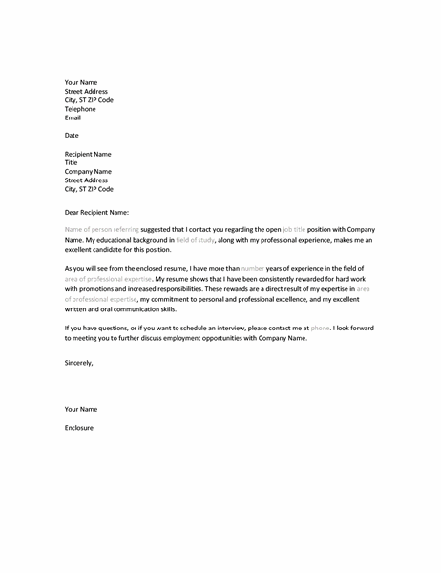  Cover Letter when referred | Learn More From Our Free Excel and Office Resources:  - Webinars: Formulas, Pivot Tables and Macros & VBA  - Blog Tutorials: Formulas, Pivot Tables, Charts, Macros, VBA, Power Query, Power Pivot, Analysis  - Excel Podcast: Interviewing the Excel Experts  MyExcelOnline

Your Name
Street Address
City, ST ZIP Code
Telephone
Email
Date
Recipient Name
Title
Company Name
Street Address
City, ST ZIP Code
Dear Recipient Name:
Name of person referring suggested that I contact you regarding the open job title position with Company Name. My educational background in field of study, along with my professional experience, makes me an excellent candidate for this position.
As you will see from the enclosed resume, I have more than number years of experience in the field of area of professional expertise. My resume shows that I have been consistently rewarded for hard work with promotions and increased responsibilities. These rewards are a direct result of my expertise in area of professional expertise, my commitment to personal and professional excellence, and my excellent written and oral communication skills.
If you have questions, or if you want to schedule an interview, please contact me at phone. I look forward to meeting you to further discuss employment opportunities with Company Name.
Sincerely,
Your Name
Enclosure

